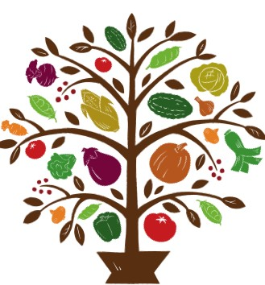Downers Legacy Seed Library

Membership Record
The Downer’s Legacy Seed Library (DLSL) is a free program committed to increasing our ability to feed ourselves by sharing biodiverse, locally-adapted seeds. The Seed Library operates on the honor system. You become a member automatically when you fill out this form and withdraw seeds to plant. We encourage all members to learn basic seed-saving techniques. We encourage that beginning seed savers grow out and return seeds from lettuce, tomato, bean or pea plants the first year. If you are unable to save your own seed, please consider donating a packet or two of fresh, commercially grown, open-pollinated (non-hybrid, non-GMO) seed to keep our library stocked. Returned seed will allow us to keep our library well stocked. We strongly recommend attending one of our seed orientation meetings.

Member Information

Name:_________________________________________________________________________________________________

Email Address:______________________________________________ Phone #_____________________________

Garden Location: ___________________________________________________________________________________

Would you like to be contacted about classes, seed swaps and other events?
Yes ______ No _______
Level of seed saving experience: Beginner _______ Intermediate _______ Advanced ______
Level of gardening: Beginner _______ Intermediate _______ Advanced ______

Would you be interested in volunteering for the DLSL? Yes ______ No ______

The Safe Seed Promise
Agriculture and seeds provide the basis upon which our lives depend. We must protect this foundation as a safe and genetically stable source for future generations. For the benefit of all farmers, gardeners, and consumers who want an alternative I promise that I do not knowingly buy, grow, share or trade genetically engineered (“GMO”) seeds or plants.

Additionally, as a member of the Downers Legacy Seed Library, I promise to grow plants and save seeds according to best practices to insure that I return viable seed that will produce plants true to the variety I label them to be.

